CSD402 | GitHub Repository Setup
Module 1 Assignment 1.2
Student: Zachary White
Professor: Darell Payne
Date: June 5, 2026
Class: CSD402

GitHub Repository Link
Repository was created and made public at:
https://github.com/DevZWhite/CSD402-306J-Java-for-Programmers

Step 1: Initialize Git Repository
Assignment Instruction
Navigate to your CSD-402 directory and initialize a new Git repository to begin tracking your files with version control

What I Did
I navigated to C:\CSD\CSD402 in the Windows Command Prompt and ran 'git init'. Git confirmed the creation of a new empty repository at C:/CSD/CSD402/.git/, setting up the hidden .git folder that will track all changes and version history going forward

Step 2: Create module-1 Directory & Verify with dir

Assignment Instruction
Navigate to your CSD-402 directory. Create a new directory named module-1 using 'mkdir module-1'. Do a directory listing to verify the new folder exists. On Windows, run: dir. Take a screenshot of the results
What I Did
I ran 'mkdir module-1' inside C:\CSD\CSD402 to create the module-1 folder. I then ran the 'dir' command to list the directory contents. The output confirmed that the README.md file (4,068 bytes) was present along with the new module-1 directory, verifying the folder structure was correctly set up before staging and committing.

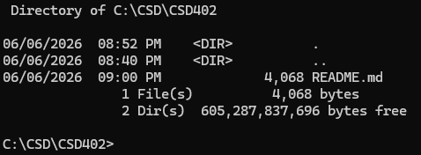
Step 3: Stage, Commit & Push to GitHub
Assignment Instruction
Check git status, stage all changes with 'git add .', commit with a message using 'git commit -m', then push to GitHub with 'git push origin main'. Check your remote repository and take a screenshot once the module-1 folder appears on GitHub.
What I Did
I ran 'git status' to confirm the working state, then used 'git add .' to stage all changes including the new module-1 directory and the Word document saved inside it. I committed with a descriptive message and pushed to the remote using 'git push origin main'. After the push completed, I verified the changes appeared on GitHub and confirmed the repository was up to date with the remote.

Step 4: GitHub Repository Confirmed on Remote

Assignment Instruction
Check your GitHub remote repository for the push. When you see module-1, click it to open and take a screenshot. Add the screenshot and copy the URL of your repository into the Word document.
What I Did
I navigated to my GitHub repository and confirmed the push was successful. The README.md was visible on the landing page, fully rendered with the Java Programming course overview, contributor section listing Zachary White as Developer and Darrell Payne as Instructor, and the complete module outline. The repository About section also correctly displayed the course description pulled from the README.

